

5th Annual Hartford HealthCare Heart & Vascular Institute
Cardiovascular Imaging Symposium



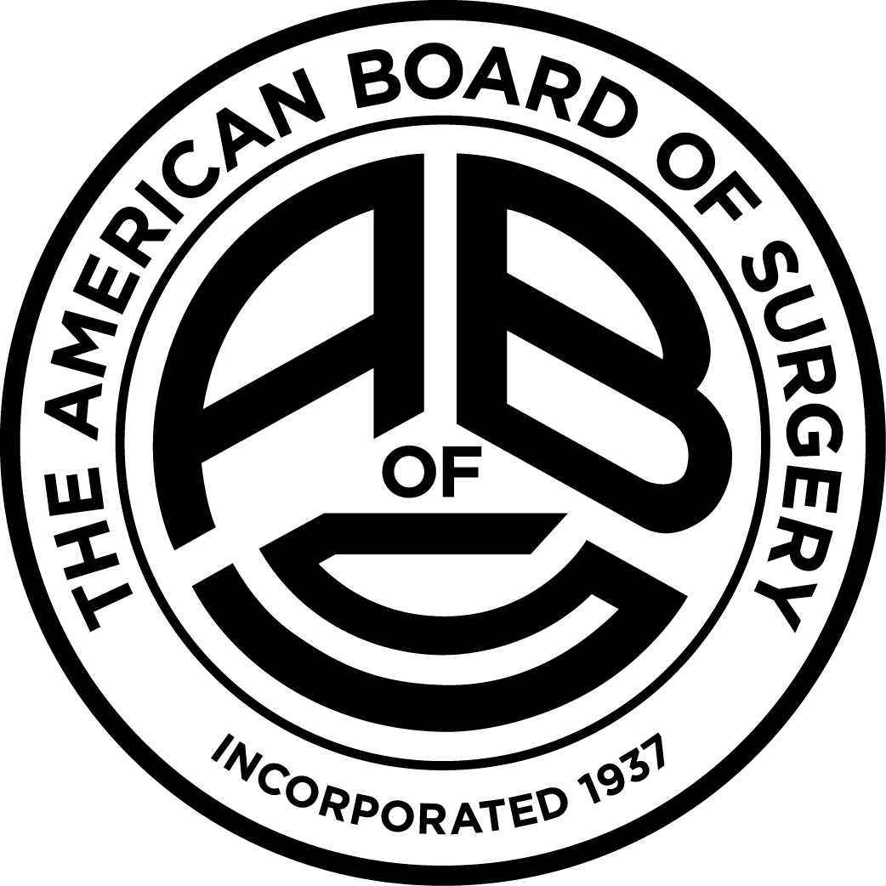

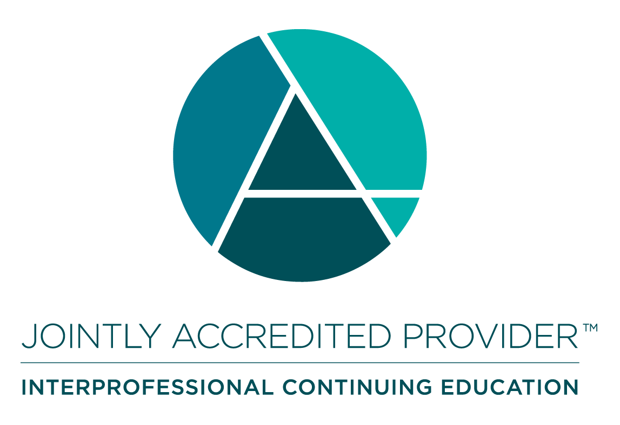

Saturday, February 7, 2026
8:00am-12:00pm
Presented via Zoom

CLICK HERE to register or scan the QR code below

Learning Objectives: As a result of participating in this Live Activity, participants should be able to:
- Appropriately order cardiac imaging tests based on common clinical indications to select most suitable modality for diagnostic accuracy and optimal patient outcomes
- Evaluate the applicability of individual cardiac imaging modalities in the diagnosis and management of various cardiac disease states, ensuring safe, evidence-based, and patient-centered decision-making
- Discuss the advanced cardiac imaging tests available within the Heart & Vascular Institute, including their indications, advantages, and roles in the diagnosis and management of complex cardiac conditions

Accreditation Statement and Credit Designation Statements: In support of improving patient care, Hartford HealthCare is jointly accredited by the Accreditation Council for Continuing Medical Education (ACCME), the Accreditation Council for Pharmacy Education (ACPE), and the American Nurses Credentialing Center (ANCC) to provide continuing education for the healthcare team.
- Physicians: Hartford HealthCare designates this live activity for a maximum of 3.5 AMA PRA Category 1 Credit™. Physicians should claim only the credit commensurate with the extent of their participation in the activity.
  - MOC for American Board of Internal Medicine (ABIM): Successful completion of this CME activity, which includes participation in the evaluation component, enables the participant to earn up to 3.5 Medical Knowledge (Interventional Cardiology) and Patient Safety MOC points in the American Board of Internal Medicine’s (ABIM) Maintenance of Certification (MOC) program. It is the CME activity provider’s responsibility to submit participant completion information to ACCME for the purpose of granting ABIM MOC credit.
  - MOC for American Board of Surgery (ABS): Successful completion of this CME activity, which includes participation in the evaluation component, enables the learner to earn credit toward the CME & Self-Assessment requirements of the American Board of Surgery’s Continuous Certification program. It is the CME activity provider's responsibility to submit learner completion information to ACCME for the purpose of granting ABS credit.
- Nurses: This activity is designated for a maximum of 3.5 ANCC contact hours.
- All Other Learners: All other learners will receive a Certificate of Participation for 3.5 hours of education. Consult your professional licensing board regarding the applicability and acceptance of certificates of participation for educational activities certified for AMA PRA Category 1 Credit™ from organizations accredited by Joint Accreditation for Interprofessional Continuing Education.
Financial Disclosures: Disclosures are on the activity registration page. All relationships have been mitigated.

